Northanger Productions
Presents
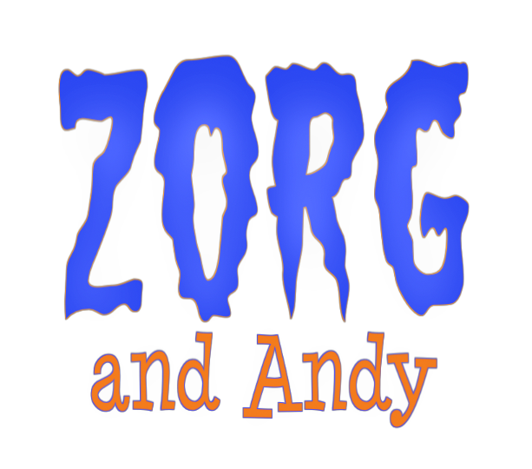
A Comedy About Love, Duty and Sacrifice.
Human Sacrifice.

Directed by Produced by Written by
Guy Davis Paula Dodd V. Z. Montengo Quentin Dodd
Guy Davis

Narrative Feature Contact
62 Minutes Guy Davis
NTSC, Color guy.davis@cox.net
USA, 2009

www.zorgandandy.com
Cast
(In Order of Appearance)
Archaeologist Dr. Jerry Howard
German Boy Austin Davis
Lead Archaeologist Doug Weatherston
Charlene Ross Julie Dietrich
Andy Scott Ganyo
Jen Kate Rudd
Pete Trevor Fanning
Researcher Wilson Bath
Colette Jennifer Wilkens
Rich Marco Noyola
Stuart Ben Ayres
Pig Nick Kraynak
Cultist Bert Douglas Weatherston
Cultist Kay Nancy R'beck
Dr. Harpax Sally Weatherston
Sorority Sister #1 Heather Lapham Kuhn
Sorority Sister #2 Sherrae Barlow
Sorority Sister #3 Shonna Stout
Sorority Sister #4 Danyella C. Davis

Crew
Directed by
Guy Davis

Written by
V. Z. Montengo

Produced by
Paula Dodd
Quentin Dodd
Guy Davis

Cinematography by
Benjamin Weatherston

Production Design by
Marco Noyola

Featuring the Music of
Kevin MacLeod
Twizzle
Coconut Monkeyrocket
Otis Fodder
LOGLINE

A student worker at a museum fights off pagan blood cults and flesh-eating beetles as he tries to recover a stolen fertility idol.

SHORT SYNOPSIS

Perpetual undergraduate Andy has one last chance to keep his financial aid: a work-study job at the mysterious Kungsbaden Museum. After a beautiful stranger steals an ancient fertility idol in his care, Andy sets out into the night to recover it. In the process, he discovers that his idyllic campus is home to a network of bloodthirsty pagan cults, all of whom are fighting over the idol.

MEDIUM SYNOPSIS

Andy Monroe has problems. He's just lost his latest work-study job and is about to lose his financial aid. His last chance to stay in college comes from an appointment to the shadowy Kungsbaden Museum of Natural History.

Andy's position is soon in jeopardy when he mistakenly hands over Zorg, an ancient fertility idol, to a beautiful stranger he mistakes for a museum employee. Jen, Andy's supervisor, discovers the blunder and sends him off into the night to recover it.

The thief turns out to be Colette, a graduate student in the Economics department. While Andy continues his search, Colette and the economists kidnap Jen and prepare to sacrifice her to Zorg in an attempt to gain supernatural influence over the tenure committee.

Andy foils their ritual and escapes with both Zorg and Jen, but the idol is soon taken again, this time by Dr. Harpax, the museum's director. Andy and Jen escape Dr. Harpax's lab full of flesh-eating beetles, only to be captured by her cohort of nubile, argumentative handmaidens. Dr. Harpax has her own cult, and Andy and Jen are to be her next victims.

With seconds left to live, Andy discovers that he's the Chosen One of Zorg, sparking a turf war between the rival cults. In the ensuing chaos, Andy and Jen summon the campus police.

When the authorities arrive, Andy and Jen realize that half the departments on campus worship Zorg in some manner. While Andy's status as the Chosen One protects them for the moment, they aren't sure what to do next. Whatever happens, they'll face it together.

LONG SYNOPSIS

Andy Monroe has problems. He’s just lost his latest work-study job, and is in serious danger of losing his financial aid. His last chance to stay in college is an assignment to the sinister Kungsbaden Museum of Natural History.

Arriving for work, Andy meets Jen, the young museum worker who will be his overseer. Andy has suffered through any number of degrading and dangerous work-study jobs, and is not surprised to learn that he’ll be treating the museum’s newest artifacts with chemicals so noxious the regular employees won’t touch them.

One of Andy’s first assignments is "Zorg," an unusual fertility idol that the museum's director has recently brought back from abroad. After spending several hours working on the sad-looking little statue, Andy is interrupted by Colette, who says she’s come to pick up the idol. Pleased to be of assistance, Andy hands it over at once.

It’s only later, when Jen comes to check on him, that Andy learns Colette does not, in fact, work for the museum. Andy has given away the director’s prize acquisition to a complete stranger from another department. This is not good. Jen rushes him out of the museum with orders to search every building.

Andy checks with Stuart and the Pig, two kingpins of campus information, for leads on Colette's identity. The Pig, a hulking figure whose nickname comes from the papier-mache pig's-head mask he wears, tells him that Colette, unbelievably, is a graduate student in the Economics department.

Andy rushes to the Economics building, where the department is attempting to gain supernatural influence over the tenure committee by performing a blood sacrifice to Zorg. Their intended victim is Jen. She had started her own investigation after Andy left, and ended up in the wrong place at the wrong time.

Andy foils their plan by threatening to expose them, then retrieves both Zorg and Jen. They flee to the safety of Jen’s apartment. The next morning, they return to the Kungsbaden to explain the situation to Dr. Arabella Harpax, the museum's director.

They discover why Dr. Harpax was so excited to have Zorg in the museum's collection: she has a cult of her own. Dr. Harpax locks them in a lab filled with angry flesh-eating beetles and goes off to summon Zorg.

Andy and Jen manage to escape, but are captured by Dr. Harpax's nubile handmaidens and made to join Colette--another of Dr. Harpax's prisoners--as sacrificial victims. Things look grim as the critical moment of the ritual approaches.

At that point, the Economics department cultists arrive, searching for Colette and disrupting the ceremony. In the confusion, Andy stumbles and falls over the statue of Zorg.

An ominous energy crackles through the air and the statue moves of its own volition. Andy, it turns out, is the "Chosen One of Zorg." This makes him a hot commodity, and the rival cults immediately begin fighting over him. Andy and Jen take advantage of the chaos to flee the museum. Outside, they collide with Stuart and the Pig, who were concerned about them and summoned the campus police to help search.

As the police lead the disheartened cultists away, Andy and Jen aren’t sure what to do next. It’s now clear that half the departments on campus worship Zorg, and Andy, as the Chosen One, is either their spiritual leader or their designated victim. Whatever happens, though, they'll face it together, and a giant man in a pig mask will always be watching out for them.

CAST BIOS
Scott Ganyo (Andy)

Besides his work in "Zorg," Scott has starred in such films as "First They Came for…" and "Shade of Grey" and is active on stage and in improv.

Scott is currently in development on a noir short film, a sci-fi comedy serial, and an action/espionage feature.

Kate Rudd (Jen)

Kate's film roles include "The Dread," "Zorg and Andy," and "Stick in the Mud."

Kate also represents LA-based motion picture company Safe Harbor Productions in Michigan.
CREW BIOS

Guy Davis, Director

Guy is a graduate of the American Film Institute. "Zorg" is his first film. At the moment, he isn't a member of any cults.

Paula Dodd, Producer

In addition to being a mechanic and a sharpshooter, Paula is also a pediatric physical therapist. This turns out to be an optimal skill set for producing an independent film.

Quentin Dodd, Producer

Quentin is the award-winning author of two young adult novels, "Beatnik Rutabagas From Beyond the Stars" and "The Princess of Neptune." "Zorg" is his first foray into film producing.

Benjamin Weatherston, Cinematographer

Ben has been a professional photographer since 1997. "Zorg and Andy" was his debut as a cinematographer. Since then, he has gone on to direct music videos and documentaries, including "Tell Everyone My Story: The Journey of Jeff Stemberger."

